BSM AY 2016-2017 Assessment
Phase 1: Assessment Plan
Learning Outcome assessed:
Learning Outcome: 05)
Students will create, analyze, and integrate relevant quantitative and qualitative information to develop and evaluate management decisions.
Assessment Method:
Semester Project used as the assignment (assignment and rubric attached)
Targeted performance, based on rubrics:
80% of students meet or exceed expectations
Evaluation Process:
Rubric:
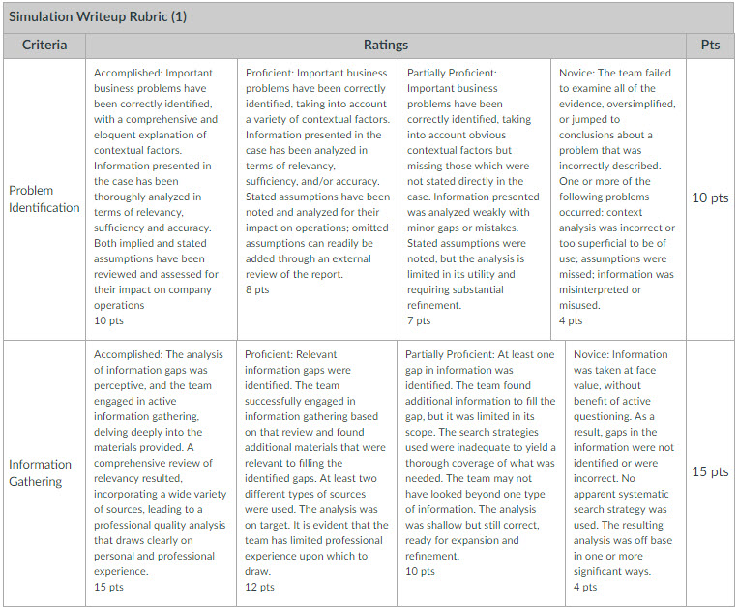

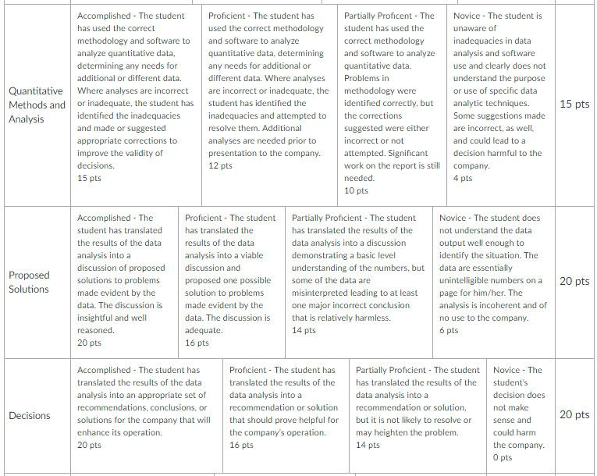

Course where learning outcome was assessed:
BSM 303-57 – Systems & Technology
Evaluator(s):
Steve Morris

Phase 2: Results Assessment and Planned Action
Results:
Eight of 13 students (61.5%) achieved the 80% and above level of achievement in the assignment.
Criterium | Points | 1 | 2 | 3 | 4 | 5 | 6 | 7 | 8 | 9 | 10 | 11 | 12 | 13
Problem ID | 10 | 9 | 8 | 7 | 7 | 2 | 8 | 7 | 10 | 3 | 3 | 5 | 7 | 8
Information Gathering | 15 | 10 | 14 | 13 | 13 | 4 | 13 | 11 | 13 | 13 | 3 | 12 | 13 | 10
Quant Methods & Analysis | 15 | 7 | 9 | 12 | 12 | 4 | 13 | 12 | 13 | 13 | 4 | 13 | 12 | 10
Proposed Solutions | 20 | 18 | 18 | 17 | 17 | 10 | 17 | 16 | 18 | 18 | 7 | 17 | 17 | 16
Decisions | 20 | 17 | 17 | 17 | 17 | 10 | 17 | 16 | 18 | 17 | 7 | 17 | 17 | 16
 |  | 76.3% | 82.5% | 82.5% | 82.5% | 37.5% | 85.0% | 77.5% | 90.0% | 80.0% | 30.0% | 80.0% | 82.5% | 75.0%

Suggested Action:
The assignment could better align with the LO. The next time the course is taught, another (or slightly modified) assignment should be used.

Phase 3: Closing the Loop

In the year that the assessment is made, this is good place to describe how the suggested actions might be evaluated in a future assessment cycle. When that cycle is complete, the results can be added to this document to finalize the report.

